JOIN
QUERY 1
select
s.Date,
s.product,
s.cate,
s.revenue,
p.manufacturer,
p.unit_price
from sales s inner join product_master p
on s.product = p.product
and s.cate = p.cate
LIMIT 50;
OUTPUT
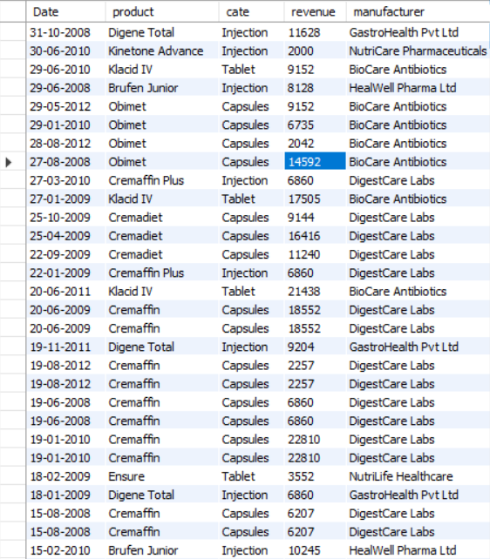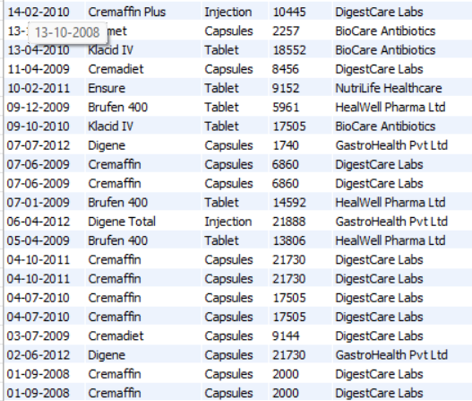

QUERY 2
SELECT
s.Product,
s.Type,
s.Quantity,
p.Unit_Price,
(s.Quantity * p.Unit_Price) AS Total_sales,
s.Revenue
FROM sales s
JOIN product_master p
ON s.Product = p.Product
AND s.Cate = p.Cate
AND s.Type = p.Type;
OUTPUT
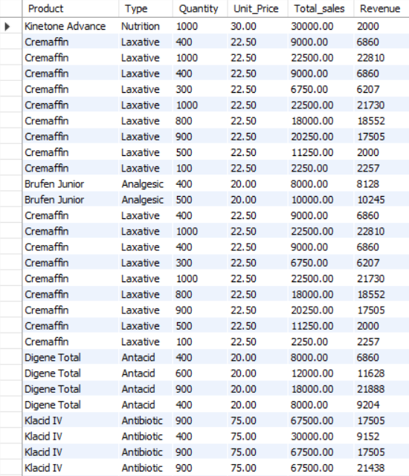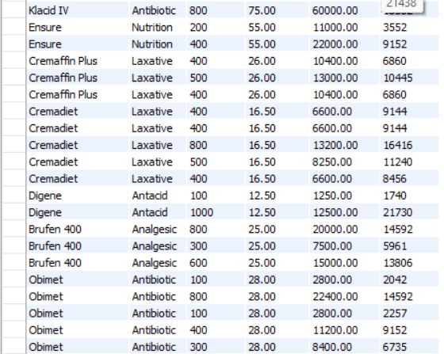

QUERY 3
SELECT
s.Product,
p.Manufacturer,
SUM(s.Revenue) AS Total_Revenue
FROM sales s
JOIN product_master p
ON s.Product = p.Product
AND s.Cate = p.Cate
AND s.Type = p.Type
GROUP BY s.Product, p.Manufacturer
ORDER BY Total_Revenue DESC
LIMIT 10;

OUTPUT
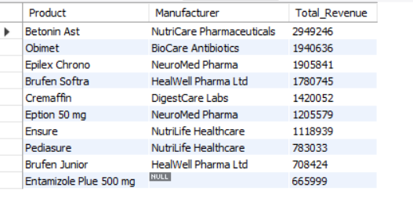

QUERY 4
SELECT
p.Manufacturer,
COUNT(*) AS Transactions,
SUM(s.Quantity) AS Total_Quantity,
SUM(s.Revenue) AS Total_Revenue
FROM sales s
JOIN product_master p
ON s.Product = p.Product
AND s.Cate = p.Cate
AND s.Type = p.Type
GROUP BY p.Manufacturer
ORDER BY Total_Revenue DESC;
OUTPUT
